|  |
| --- |
| **National University of Computer and Emerging Sciences** |
| Lab Manual 5.2  “Views” |
|  |
| Database Systems |
| Spring 2022 |

Table of Contents

1 Views 3

1.1 Create a View 3

1.2 Use a View 4

1.3 Alter a View 6

1.4 Insert Update Delete Data Through View 7

1.5 With Check Option 8

# Views

In previous lab manuals you learned how to write select query to retrieve data. While some select queries you write might be used only for one time activity, some select queries are used again and again within your application/environment. Some of these queries that you reuse within your environment contain complex logic, and you would not want to rewrite them every time you use them. SQL server allows you to store a SELECT statement within a database using an object called a view. In this section you will learn how to CREATE as view, modify data through a view, how to ALTER a view, and how to use a view.

We will use the Student schema for all the examples (given in last lab)

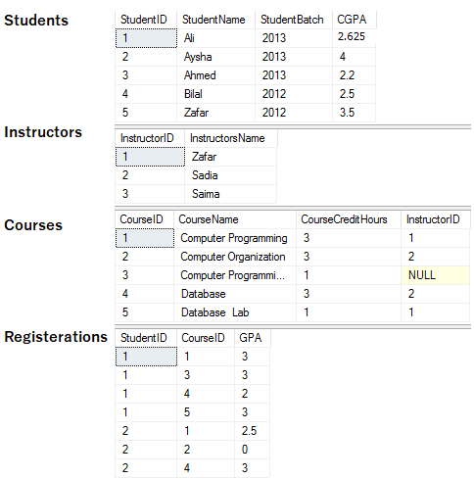

## Create a View

View is simple a select statement that has been given a name and stored in dataset. View is also called a virtual table, because there is no data in the view itself, it’s just a select query that get data from base tables

create View <ViewName>

AS

<Select Query>

When you excute a create view statement you should get command successful notification, just like when you created a table.

TRY IT

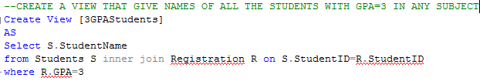

Here the base tables are Student and Registration

TRY THIS

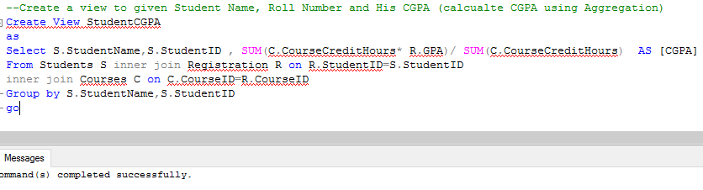

Here the base tables are Students, Registration and Courses.

**NOTE: EVERY COLUMN RETURNED BY SELECT QUERY OF VIEW SHOULD HAVE UNIQUE NAME, DERIVED COLUMNS SHOULD BE GIVEN ALIAS. COLUMNS WITH SAME NAMES SHOULD ALSO BE GIVEN DISTINCT ALIAS

## Use a View

As already told view are virtual tables. You can use them as regular tables in SELECT statement.

TRY IT

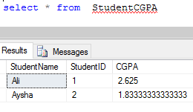

**NOTE: this data was not present in StudentCGPA view, rather when you select a view, the Select query in body of view is executed and result is returned.

Similarly you can join views with tables of views, you can take aggregates of view.

TRY IT

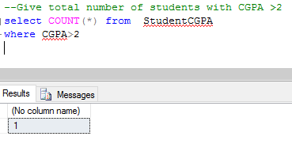

## Alter a View

You can change the select query of your view by using following syntax

Alter View <ViewName>

AS

<Select Query>

TRY IT

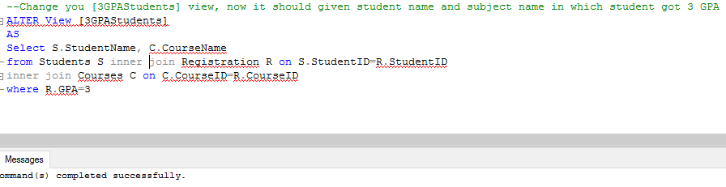

Now retrived the data from view

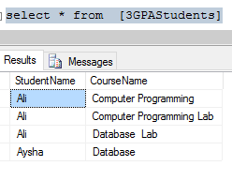

## Insert Update Delete Data Through View

As view is a virtual table and has no data of its own, if you run delete insert or update query on view, the data in base table will change (if the change is feasible and is not violating any constraint). If the select query in View has joins and aggregates then delete insert or update would not work.

Read Elmasri Chapter 5 for more details.

TRY IT

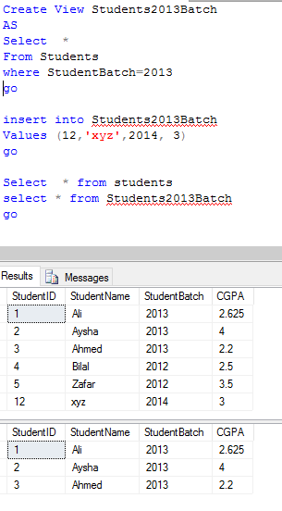

## With Check Option

With check option ensures that the only data manipulation that can occur through view also must be retrievable though that view.

In previous example the XYZ student we added though the view, was not retrievable thought view. If we add with check option that insertion would not have been possible though view.

TRY IT

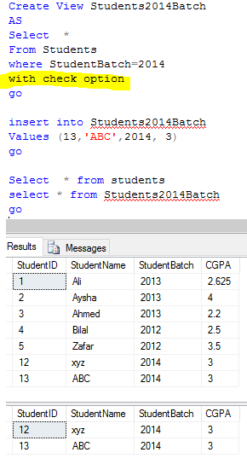

Now try adding a row that thought Student2014Batch that will not be retrievable though it

TRY IT

